Day 6
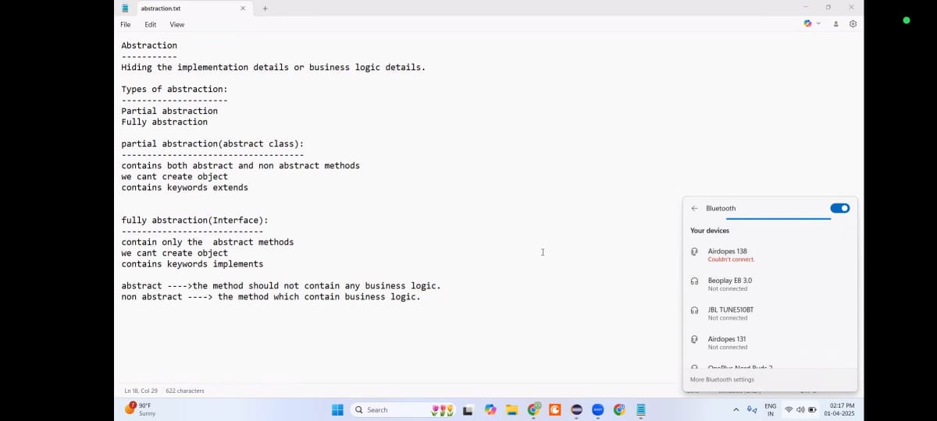
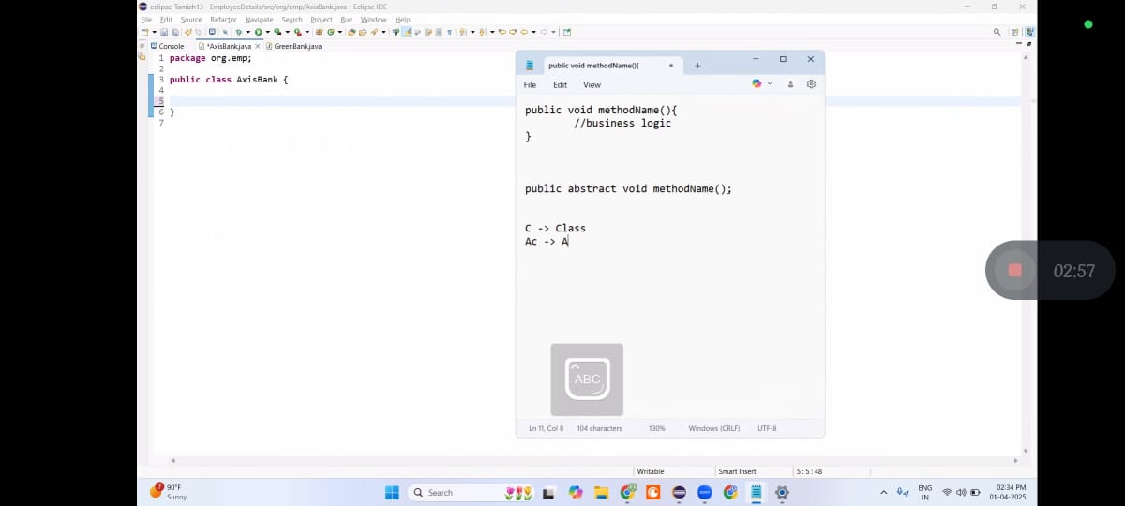
AC Abstract class
C Class

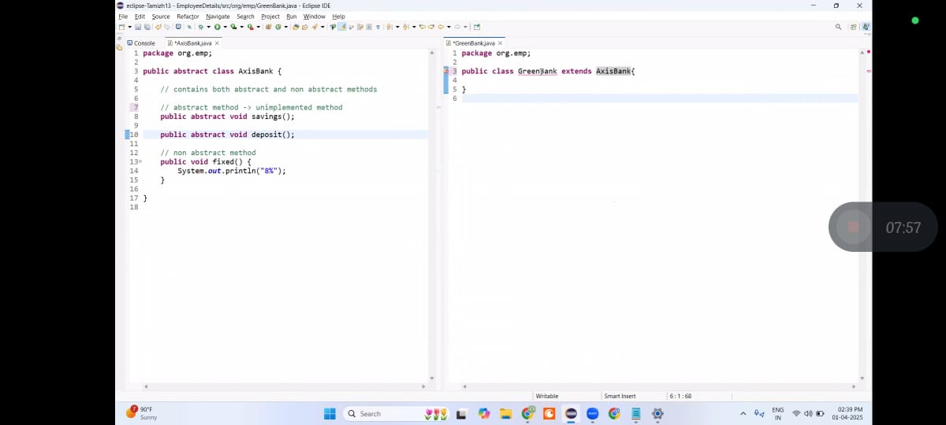
If GreenBank show error Right click click 1 option
------------------------------------------------------------------------
1) Partial Abstraction (Abstract class)
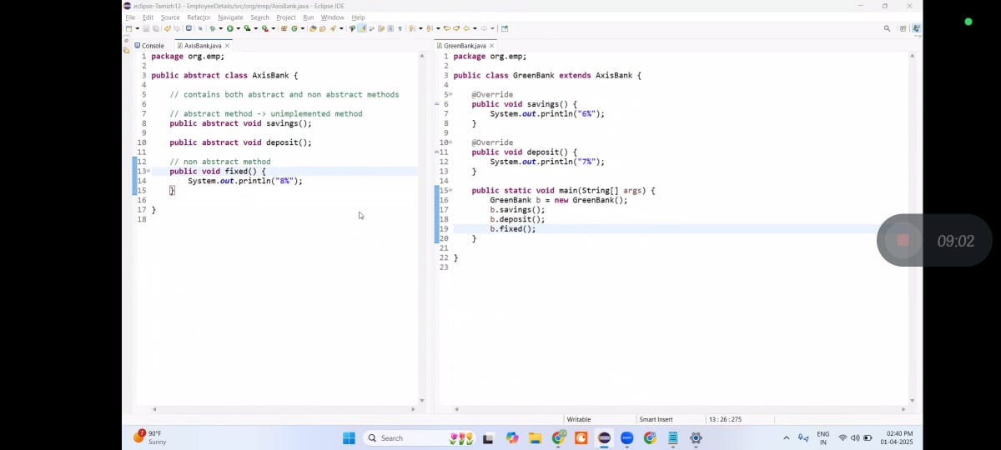

2) Fully Abstraction (Interface)
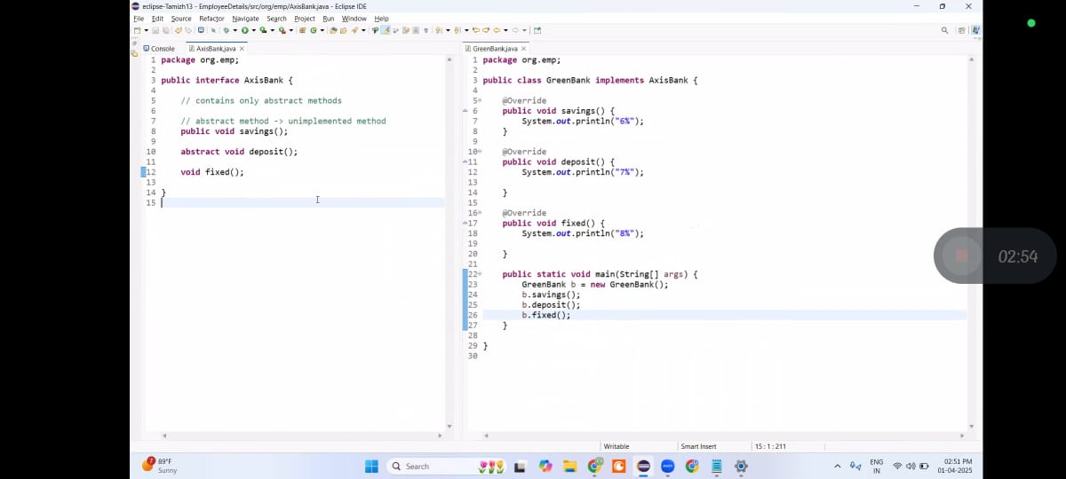
====================================================================================
Inheritance
3) Multiple Inheritance
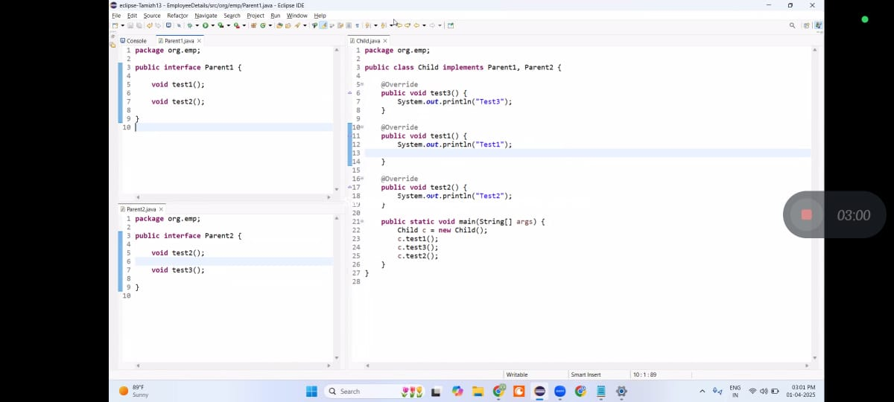
Task & Answer in Day 5

